Exercise 1
function y = DTFT(x, n, w)
y=zeros(1,length(w));
for k=1:length(w)
y(k)=sum(x.*exp(-1j*w(k)*n));
end
end

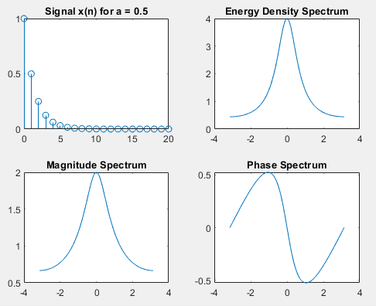
Exercise 2
n = 0:20;
w = -pi:0.001*pi:pi;

a = 0.5;
x = a.^n;
X_w = DTFT(x, n, w);
Sxx = abs(X_w).^2;

figure;
subplot(2,2,1);
stem(n, x);title(['Signal x(n) for a = 0.5']);
subplot(2,2,2);
plot(w, Sxx);title('Energy Density Spectrum');
subplot(2,2,3);
plot(w, abs(X_w));title('Magnitude Spectrum');
subplot(2,2,4);
plot(w, angle(X_w));title('Phase Spectrum');

a = -0.5;
w = -pi:0.001:pi;
x = a.^n;
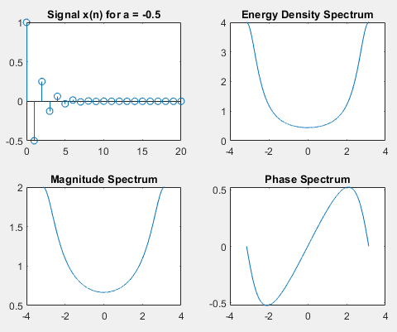
X_w = DTFT(x, n, w);
Sxx = abs(X_w).^2;

figure;
subplot(2,2,1);
stem(n, x);title(['Signal x(n) for a = -0.5']);
subplot(2,2,2);
plot(w, Sxx);title('Energy Density Spectrum');
subplot(2,2,3);
plot(w, abs(X_w));title('Magnitude Spectrum');
subplot(2,2,4);
plot(w, angle(X_w));title('Phase Spectrum');

function y = DTFT(x, n, w)
y=zeros(1,length(w));
for k=1:length(w)
y(k)=sum(x.*exp(-1j*w(k)*n));
end
end

Exercise 3
f = 1/8;
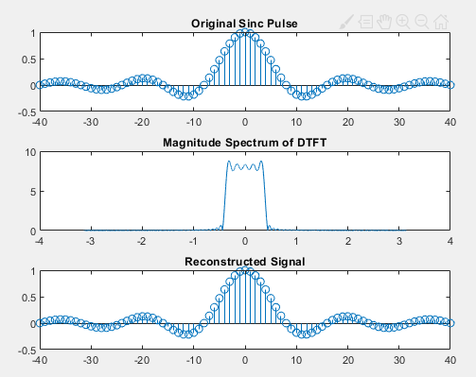
n = -40:40;
x = sinc(f * n);

w = -pi:0.001/pi:pi;
X_w = DTFT(x, n, w);

dw = 0.001 / pi;
x_recon=zeros(size(n));

for i=1:length(n)
x_recon(i)=(1/(2*pi))*sum(X_w.*exp(1j*w*n(i))*dw);
end

figure;
subplot(3,1,1);
stem(n, x);title('Original Sinc Pulse');

subplot(3,1,2);
plot(w, abs(X_w));title('Magnitude Spectrum of DTFT');

subplot(3,1,3);
stem(n, x_recon);title('Reconstructed Signal');

function y = DTFT(x, n, w)
y=zeros(1,length(w));
for k=1:length(w)
y(k)=sum(x.*exp(-1j*w(k)*n));
end
end
Exercise 4
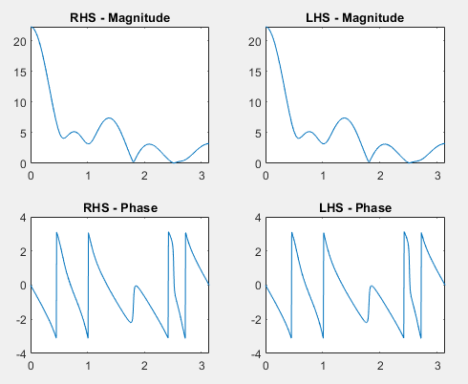
n = 0:10;
w = (0:500) * pi / 500;
a = 3;
b = 2;

x1 = rand(1, length(n));
x2 = rand(1, length(n));
X1_w = DTFT(x1, n, w);
X2_w = DTFT(x2, n, w);

X_sum_w = a * X1_w + b * X2_w;
x_sum = a * x1 + b * x2;
X_combined_w = DTFT(x_sum, n, w);

figure;
subplot(2,2,1);
plot(w, abs(X_sum_w));
title('RHS - Magnitude');
subplot(2,2,2);
plot(w, abs(X_combined_w));
title('LHS - Magnitude');
subplot(2,2,3);
plot(w, angle(X_sum_w));
title('RHS - Phase');
subplot(2,2,4);
plot(w, angle(X_combined_w));
title('LHS - Phase');

function y = DTFT(x, n, w)
y=zeros(1,length(w));
for k=1:length(w)
y(k)=sum(x.*exp(-1j*w(k)*n));
end
end

Exercise 5
n = -1:1;
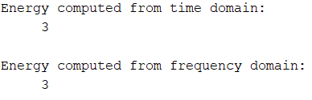
x = [1 1 1];
w = 0:pi/100:2*pi;
E_time = sum(abs(x).^2);
X_w = DTFT(x, n, w);
X_w_mag2 = abs(X_w).^2;
E_freq = (1 / (2 * pi)) * trapz(w, X_w_mag2);
disp('Energy computed from time domain: ');
disp(E_time);
disp('Energy computed from frequency domain:');
disp(E_freq);

function y = DTFT(x, n, w)
y=zeros(1,length(w));
for k=1:length(w)
y(k)=sum(x.*exp(-1j*w(k)*n));
end
end

Exercise 6
n = -3:3;
x = [0 0 1 1 0 0 0];
n_shifted = n + 4;
x_shifted = x;

w = -pi:0.001/pi:pi;
X_w = DTFT(x, n, w);
X_shifted_w = X_w .* exp(-1j * w * 4);
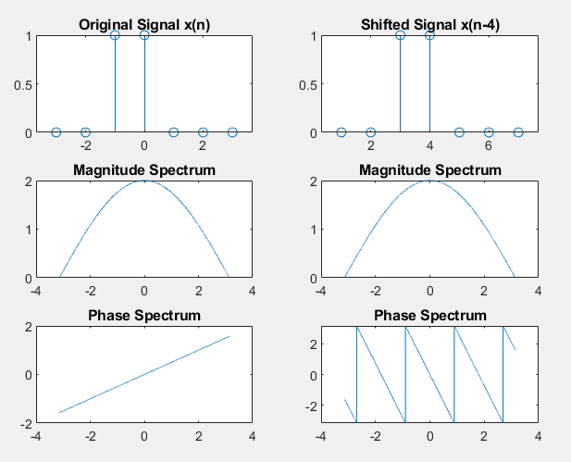
figure;
subplot(3,2,1);
stem(n, x);
title('Original Signal x(n)');
subplot(3,2,2);
stem(n_shifted, x_shifted);
title('Shifted Signal x(n-4)');
subplot(3,2,3);
plot(w, abs(X_w));
title('Magnitude Spectrum');
subplot(3,2,4);
plot(w, abs(X_shifted_w));
title('Magnitude Spectrum');
subplot(3,2,5);
plot(w, angle(X_w));
title('Phase Spectrum');
subplot(3,2,6);
plot(w, angle(X_shifted_w));
title('Phase Spectrum');

function y = DTFT(x, n, w)
y=zeros(1,length(w));
for k=1:length(w)
y(k)=sum(x.*exp(-1j*w(k)*n));
end
end
Post Lab
x = [1/3, 1/3, 1/3];
n = [0 1 2];
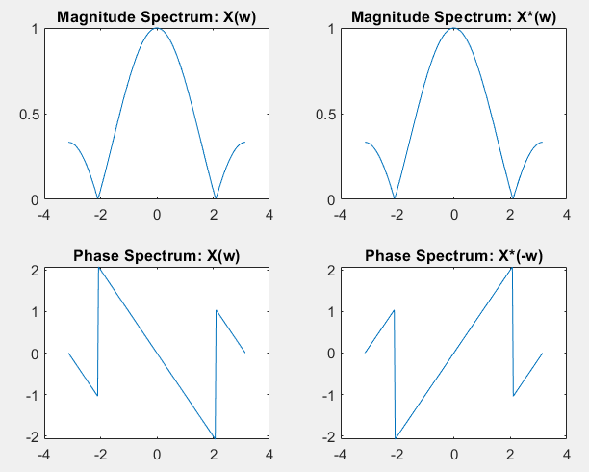
w = -pi:pi/100:pi;

X_w = DTFT(x, n, w);

x_conjugate = conj(x);
X_w_conjugate = DTFT(x_conjugate, n, w);

X_w_neg = conj(X_w);

figure;
subplot(2,2,1);
plot(w, abs(X_w));
title('Magnitude Spectrum: X(w)');
subplot(2,2,2);
plot(-w, abs(X_w_conjugate));
title('Magnitude Spectrum: X*(w)');

subplot(2,2,3);
plot(w, angle(X_w));
title('Phase Spectrum: X(w)');
subplot(2,2,4);
plot(-w, angle(X_w_conjugate));
title('Phase Spectrum: X*(-w)');

function y = DTFT(x, n, w)
y=zeros(1,length(w));
for k=1:length(w)
y(k)=sum(x.*exp(-1j*w(k)*n));
end
end

